**6. Develop a system using UML for implementing E-Ticketing System. This is to be used by the passenger for reserving the tickets for their travel. This E-ticketing is organized by the central system. The information is provided by the railway reservation system.**

**AIM:-**

To develop a system using UML for E-TICKETING SYSTEM.

UML DESIGNS:-

1.ACTIVITY DIAGRAM:

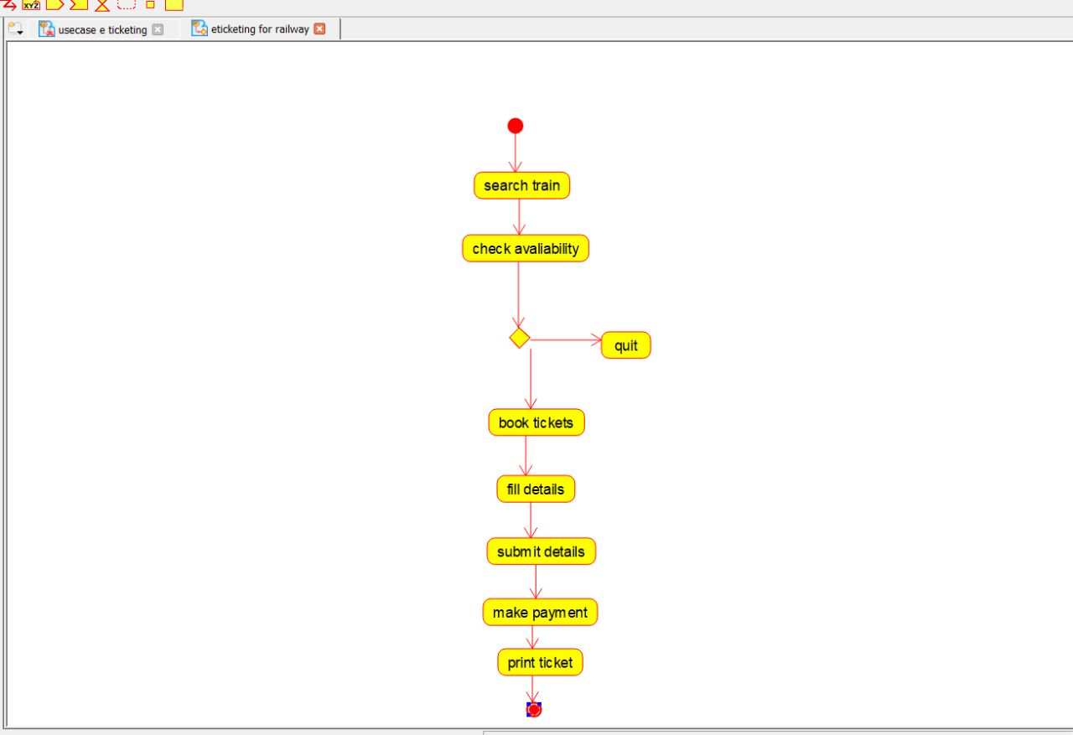

2.USECASE DIAGRAM:

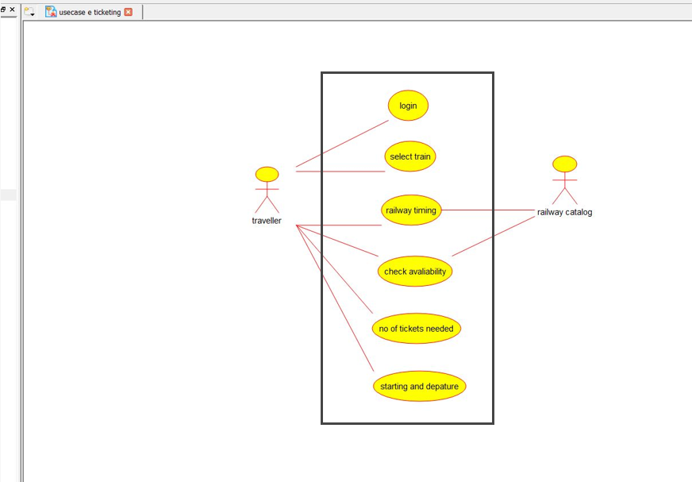

3.COMPONENT DIAGRAM:

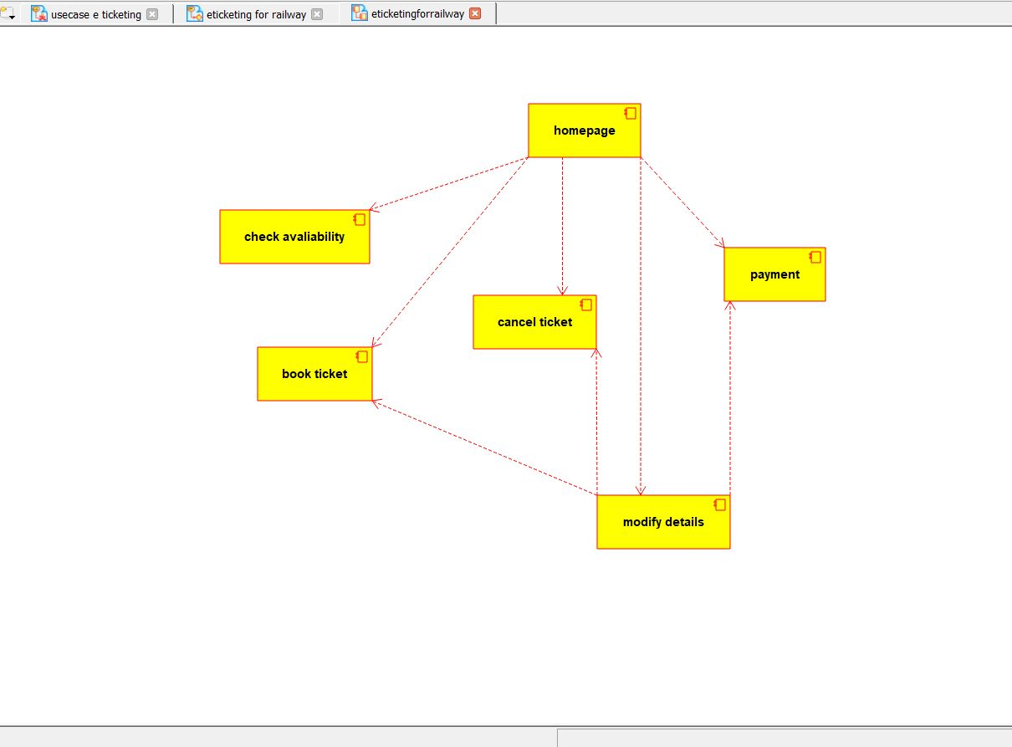

4.CLASS DIAGRAM:

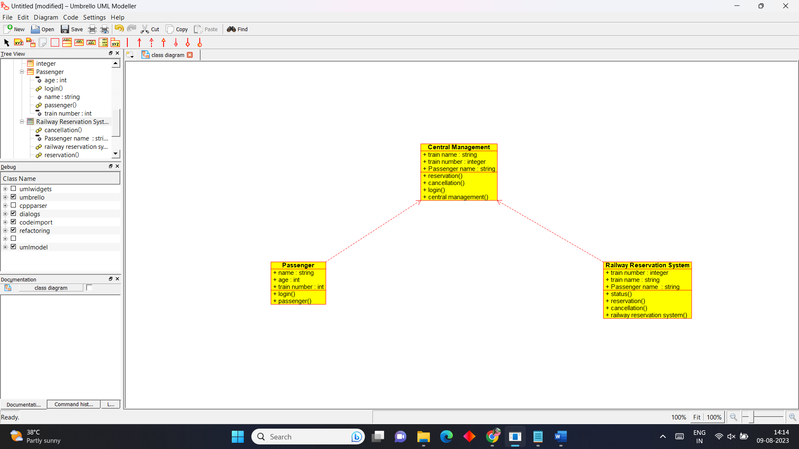

5.STATE DIAGRAM:

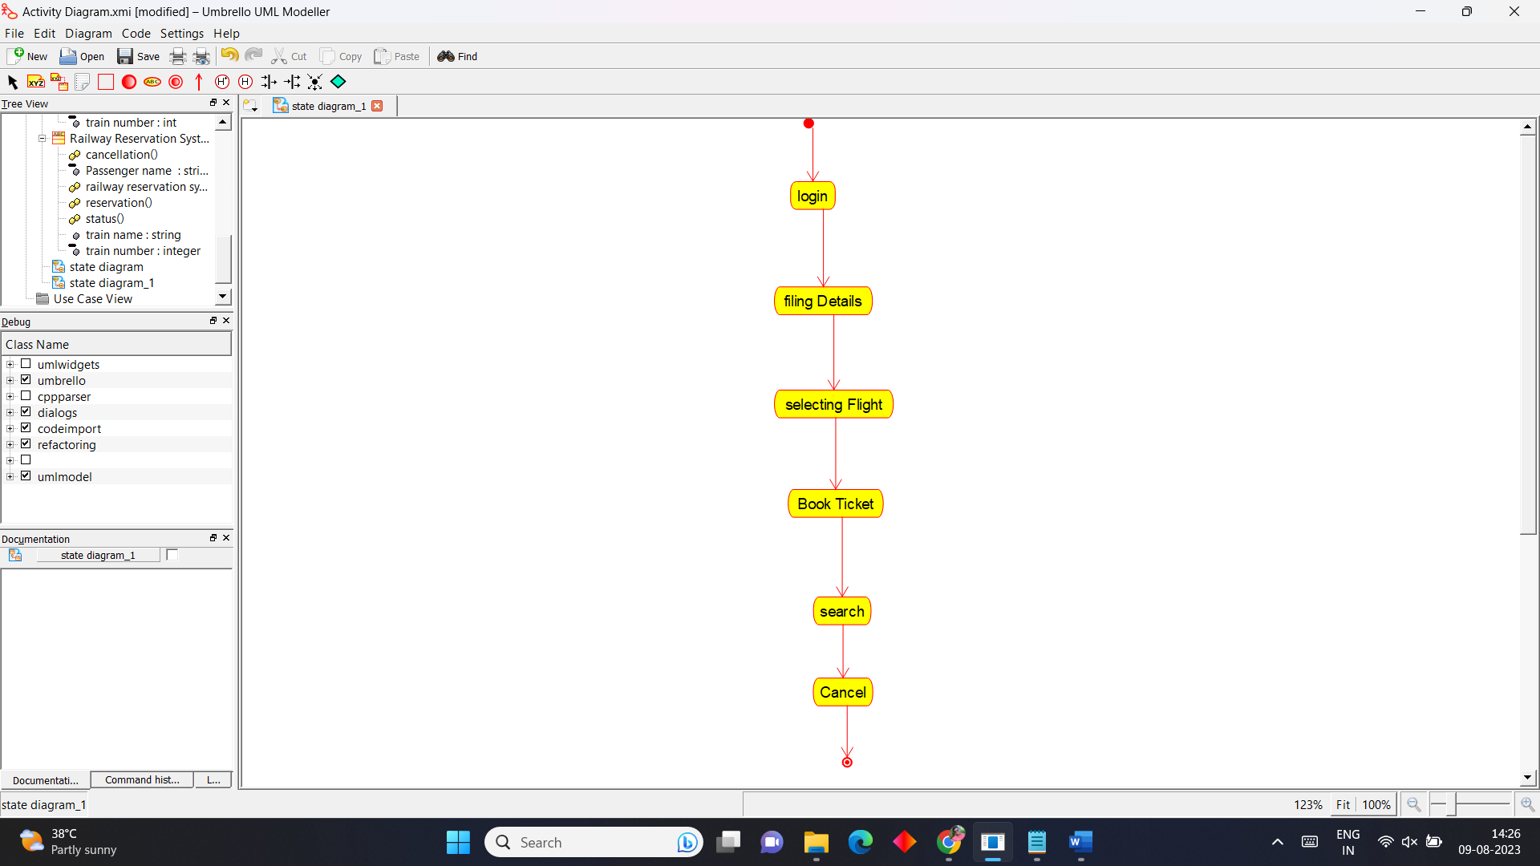

6.SEQUENCE DIAGRAM:

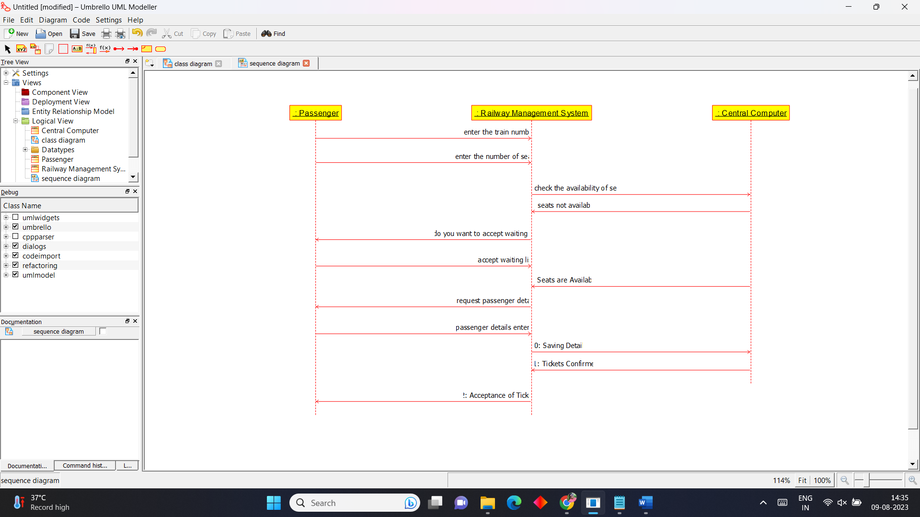

**7.** **Develop a system using UML for implementing Credit Card Processing System. In this system, the cardholder can purchase items and pays the bill with the aid of a credit card. The cashier should accept the card and proceed with the transaction using the central system. The bill is to be verified and the items are delivered to the cardholder based on it.**

**AIM:-**

To develop a system using UML for CREDIT CARD PROCESSING SYSTEM.

UML DESIGNS:-

1.USE CASE DIAGRAM:

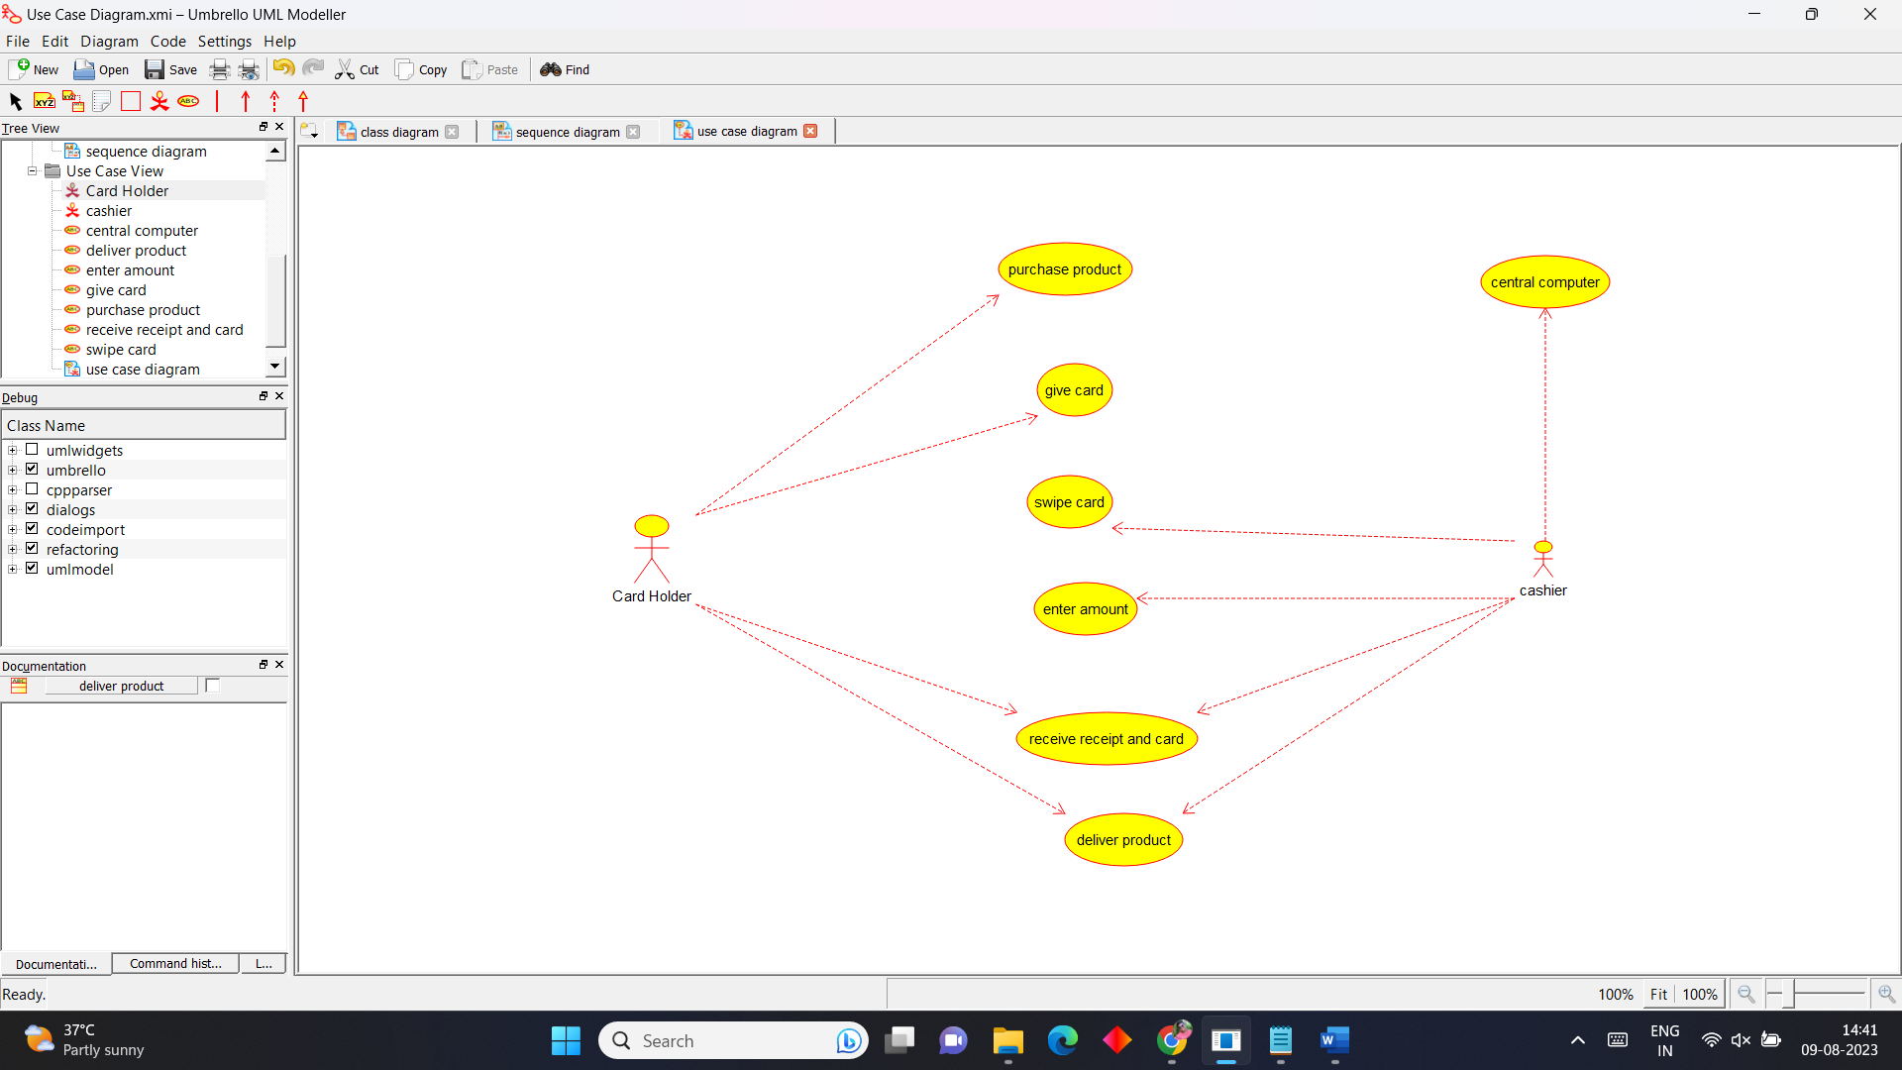

2.ACTIVITY DIAGRAM:

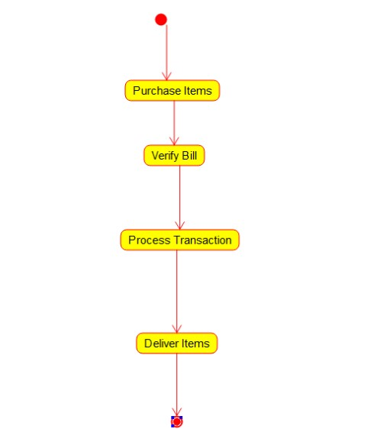

3.CLASS DIAGRAM:

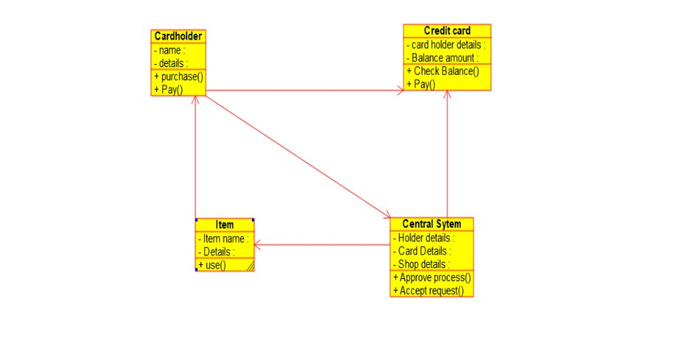

4.COMPONENT DIAGRAM: 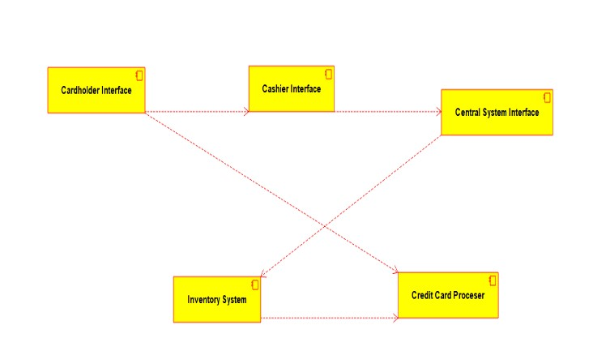

5.STATE DIAGRAM:

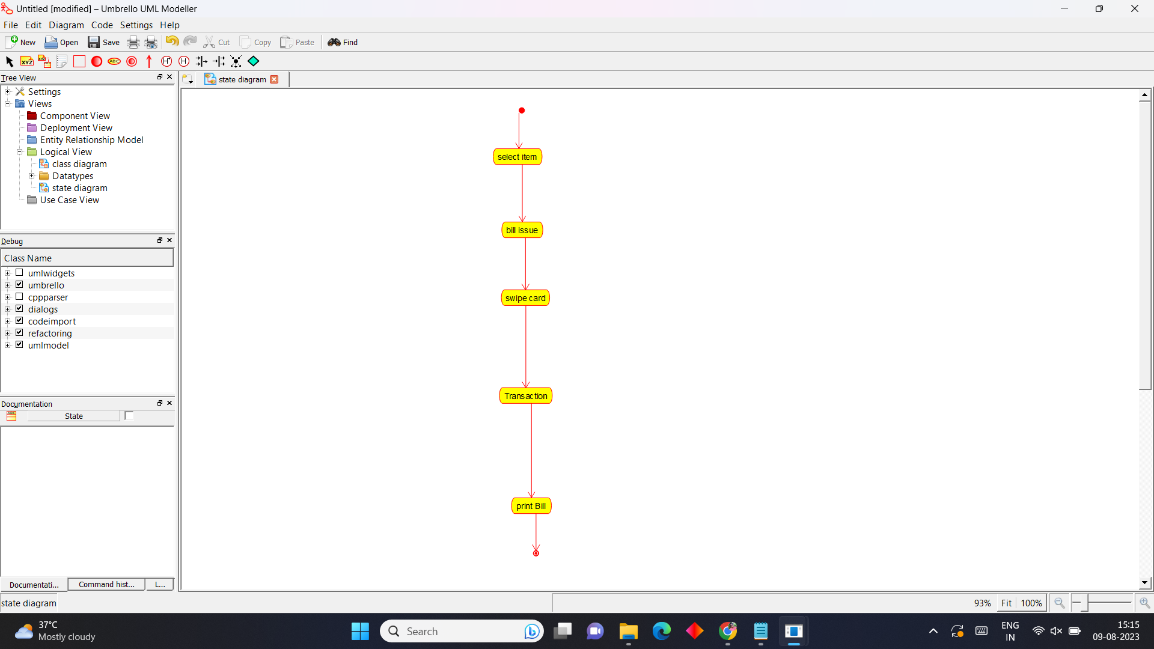

6.SEQUENCE DIAGRAM:

